**“OneOpinion-Master” Installation Guide**

We are using **Firebase** for the database and **emberJS** framework for the frontend development.

**Installation of FireBase -**

**Step 1 :-** Go to this website[**https://firebase.google.com/**](https://firebase.google.com/)

**Step 2 :-** Now click on GET STARTED then URL will automatically redirect into this website[**https://console.firebase.google.com/u/0/**](https://console.firebase.google.com/u/0/%20)

**Step 3 :-** Here you will find ADD PROJECT button, click on Add Project and choose *project name* and the *country*.Here you can change the project-id as well (It’s totally a user’s choice). Then click Create Project so it will take some time to build a project. When your project will be ready you will see this screen just like this.

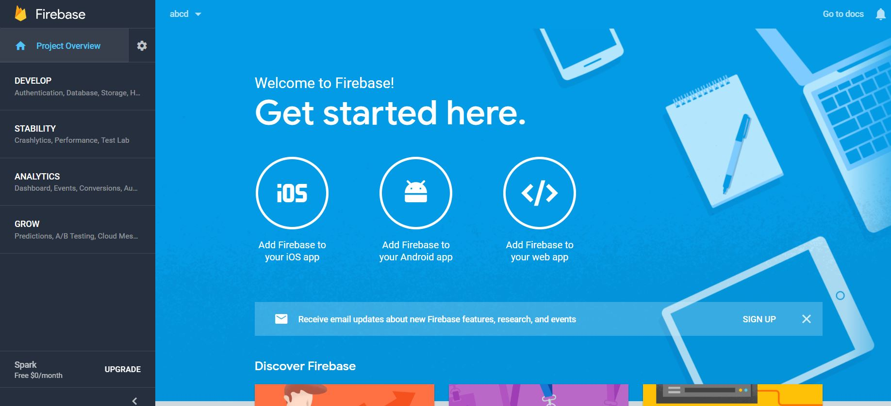

**Installation of Ember.JS:**

Step 1: Start your NODEJS command prompt.

Step 2: Go to the GitHub at following address [***https://github.com/swapnilds23/OneOpinion***](https://github.com/swapnilds23/OneOpinion) and download source folder.

Step 3: Now install all the ember dependencies through command line by executing ***npm Install*** command.

Step 4: Sign In into your firebase account to connect the database.